Amazon Freevee Debuts Official Trailer and Key Art for Post Malone: Runaway, Available to Stream August 12

The one-hour music documentary hails from Emmy-winning studio Pulse Films and BAFTA-nominated director Hector Dockrill

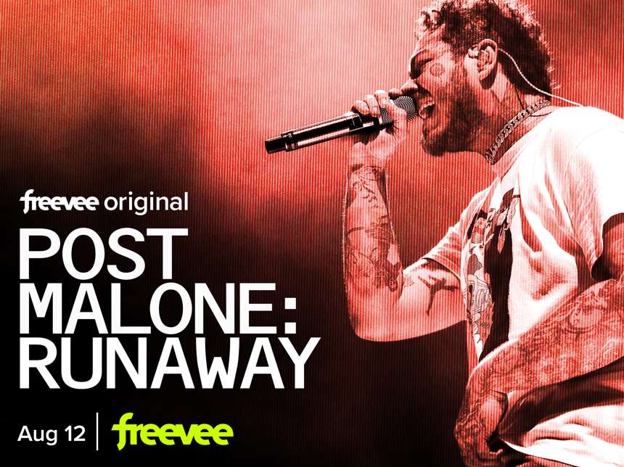

​​Watch Official Trailer HERE
Key Art/Episodic Images Available HERE
Available via Screeners.com

FEATURES EMBARGOED UNTIL FRIDAY, AUGUST 5 AT 9:00 A.M. EDT/6:00 A.M. PDT
REVIEWS EMBARGOED UNTIL THURSDAY, AUGUST 11 AT 9:00 A.M. EDT/6:00 A.M. PDT

Amazon Freevee announced the August 12 premiere date for Post Malone: Runaway, a one-hour documentary from Emmy award-winning studio Pulse Films, a part of Vice Media Group, showcasing the story of Grammy-nominated, three-times diamond-certified artist Post Malone’s first arena tour. The film, which marks the service’s second Original movie, will feature exclusive backstage access, live performances, and intimate interviews. The official trailer and screeners are available now.

In September 2019, Post Malone’s Runaway Tour marked a pivotal moment in the evolution of his career, where he stepped up and became this generation's undisputed rock star. Filmed just before COVID-19 grounded the tour—and whole world—to a halt, the film reveals unforgettable backstage access and peels back the curtain on Post Malone’s world and his epic 37-date North American tour. The film takes viewers into the eye of the touring storm, while digging deep into the stories, songs, and characters that made up this now-legendary tour.

From Pulse Films and Federal Films, Post Malone: Runaway was created by BAFTA-nominated Hector Dockrill and written and produced by Sam Bridger and Casey Engelhardt. The film is executive produced by Dre London, Austin Rosen, Bobby Greenleaf, and Marisa Clifford.

“I already knew Post Malone was a force before going on tour. But then, after spending time with him, unfiltered, close, and personal, I very quickly realized he's unlike anything the world has seen before. He's a polymath, loyal to his art, a true 'rock star,’” said director Hector Dockrill. “Being on tour with Post is like every emotion hitting you at once, it's intense and it's wild, and our vision was to pull fans into the experience just enough to get a glimpse of this, while leaving the rest to the imagination.”

“Post Malone is a once-in-a-generation artist. A musician who has consistently defied categorization and set his own creative agenda. At Pulse Films, we have always been drawn to creatives that break the mold, and so working with Post, his team, and label to document this legendary tour has been a privilege,” said Sam Bridger, head of music documentaries, Pulse Films.

Follow Amazon Freevee, formerly IMDb TV:
TWITTER | INSTAGRAM | FACEBOOK
Freevee PR Contacts:
Dezmon Gilmore
dezmongi@amazon.com
Austin Kim
kimaust@amazon.com
SMITHHOUSE for Amazon Freevee:
freevee@smithhousestrategy.com
Synopsis: In September 2019, one of the most important artists of his generation embarked on a 37-date tour in North America. Filmed just before COVID-19 ground the world to a halt, the film reveals exclusive and unforgettable backstage access, live performances, intimate interviews, and peels back the curtain of Post Malone’s world, taking viewers into the heart of this legendary tour.

About Post Malone

A 3x-diamond-certified, Dallas, TX artist Post Malone emerged in 2015 with a genre-less brew that inspired a movement, delivering multiple #1 debuts. 2019’s Hollywood’s Bleeding [Republic Records] arrived with platinum status and eventually went on to go triple-platinum, following the immense success of the triple-Platinum beerbongs & Bentleys, which also landed at #1 a year prior. In the wake of beerbongs & Bentleys, Post crushed a record in place for 54 years. He charted nine songs in the Top 20 of the Hot 100, notching “the most songs in the Top 20 of the Hot 100 ever.” Moreover, he also trounced the record for most simultaneous Top 40 Hot 100 hits with 14. His catalog comprises the GRAMMY® Award-nominated records "Circles" (4x-platinum), “rockstar” [feat. 21 Savage” (Diamond), “Sunflower (Spider-Man: Into The Spider-Verse)” [feat. Swae Lee] (Diamond) and Congratulations [feat. Quavo] (Diamond), and much more. Post kicks off his next era and paves the way for his fourth full-length album with the blockbuster single “One Right Now” [with The Weeknd].

Amazon Freevee, formerly IMDb TV
Amazon Freevee is a streaming video service with thousands of premium movies and TV shows, including Originals and FAST channels, available anytime, for free.

●Expansive Catalog: Expansive Catalog: Amazon Freevee is a modern television network, offering viewers ambitious Originals, including Bosch: Legacy, the spinoff of the Prime Video series Bosch; the court program Judy Justice; the reality series Hollywood Houselift with Jeff Lewis; rom-com feature Love Accidentally; the music docuseries Luke Bryan: My Dirt Road Diary; the heist drama Leverage: Redemption; the true-crime docuseries Moment of Truth; the buddy-cop drama Pretty Hard Cases; the zany true-crime docuseries Bug Out; the spy thriller Alex Rider; the Australian crime drama Troppo; and the sports docuseries UNINTERRUPTED’s Top Class: The Life and Times of the Sierra Canyon Trailblazers. Combined with an always updating library of broadly appealing hit movies and TV shows across a wide selection of genres, and a catalog of more than 75 FAST channels, Freevee delivers customers the content they would expect to see on a paid service.
●Free: The entire catalog of content on the service is free. No paid subscriptions necessary.
●Limited Ads: Freevee provides customers highly sought content supported by limited advertising.
●Instant Access: Freevee is available as an app on Fire TV, Fire Tablets, and as a free Channel within Prime Video, across hundreds of devices. Freevee is also available as an app on third party devices including Roku, Samsung smart TVs (2017-2021 models), Apple TV 4K, Apple TV HD, Comcast’s Xfinity Flex, Xfinity X1, Chromecast with Google TV, NVIDIA SHIELD and other Android TV devices, Xbox One, Xbox Series X|S, PlayStation 4 and PlayStation 5 consoles, as well as LG Smart TVs (2018-2021 models). The app is also available on iPhone, iPad, and Android mobile devices.

To learn more about Amazon Freevee, visit www.amazon.com/freevee and follow @AmazonFreevee.

# # #

