SEE IT NOW STUDIOS AND PARAMOUNT+ TO PRESENT
SUPERPOWER, A FILM BY SEAN PENN

Documentary Feature Captures Ukrainian President Volodymr Zelensky and
Sean Penn as the First Russian Bombs Rocked Kyiv

Film Will Premiere Exclusively on Paramount+ Monday, September 18

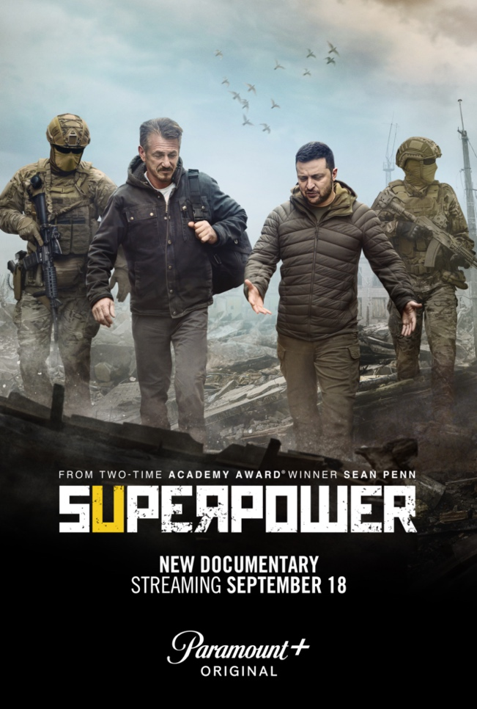

Watch the Trailer

August 23, 2023 – See It Now Studios today announced that SUPERPOWER, the documentary feature film co-directed by Sean Penn and Aaron Kaufman about Ukraine’s fight to maintain freedom from Russia, will premiere exclusively on Paramount+ in the U.S. on Monday, September 18. SUPERPOWER is a heart-wrenching glimpse into a country fighting for its freedom. It features a series of intimate interviews done by Penn with Ukrainian President Volodymyr Zelensky over seven trips made in the past two years.

While still in production, SUPERPOWER previewed its work in progress at the Berlin International Film Festival. The now completed film documents the months before the invasion, the hours leading up to the moment Russian President Vladimir Putin launched rockets into Kyiv and the devastating aftermath that continues today.

When filming began in late 2021, Putin’s full-scale invasion of Ukraine was just a looming, if seemingly distant, threat. Penn traveled to Ukraine to learn more about Zelensky, the actor and comedian who played an unlikely presidential candidate on television before becoming the actual President of Ukraine. At that point, Americans primarily knew Zelensky for his rebuffing of President Trump’s attempts at coercion. But on February 24, 2022, while Penn was filming in Kyiv, Russia’s army attacked and shocked the world. As explosions rocked the city, Penn became a front-row witness to this historic “David and Goliath'' struggle.

“We set out to tell a lighthearted tale of this comedic actor who had been elected President of Ukraine and instead became witness to a historic leader and his country’s war for freedom,” said Penn. “When you step into a country of such incredible unity, you realize what we (in the United States) have all been missing.”

“What makes this film extraordinary is the immersive nature of Penn’s journey, which is a hallmark of our studio,” says Susan Zirinsky, President of See It Now Studios. “Being in the President’s bunker the night of the invasion to speak firsthand with Zelensky whose country has been facing down the bloodiest invasion in Europe since World War II, Penn appreciated the extraordinarily historic weight of this moment and understood, from that moment on, the world had changed.”

In SUPERPOWER, Penn talks with veterans from the 2014 invasion; a widow who lost her husband at Maidan; musicians in Kyiv bracing themselves for Putin’s attacks; and key political players. After the current invasion, Penn visits people whose homes and families are destroyed. He ventures to the front lines, where he witnesses soldiers putting their lives on the line, including women who’ve taken up arms to become snipers and children training to defend their country. He also talks to top Ukrainian, Polish and U.S. government officials.
SUPERPOWER presents Zelensky as a leader stepping up to embrace his country’s destiny. Overnight, he became the most significant wartime leader of the modern era. This one-time actor turned president is leading his country in conflict with a nuclear superpower, becoming a crucible of history. Amid moments of levity, inspiration and on-the-ground storytelling, the film shows that Ukraine’s superpower lies in the strength of its leader, its people and ultimately its heart.

The film was financed by FIFTH SEASON and VICE News, with VICE Studios and Projected Picture Works producing alongside Penn, Billy Smith, Sergei Bespalov, Danny Gabai and Lauren Terp. Executive Producers are Kate Ward, Katie Peck, Andrew Freston, Bruce Dixon, Hozefa Lokhandwala, Subrata De, Susan Zirinsky, Terence Wrong, Anthony Gudas, Chad A. Verdi and Sasha Cherniavsky. FIFTH SEASON is handling the global distribution of the film.

About Paramount+
Paramount+, a direct-to-consumer digital subscription video on-demand and live streaming service, combines live sports, breaking news and a Mountain of Entertainment™. The premium streaming service features an expansive library of original series, hit shows and popular movies across every genre from world-renowned brands and production studios, including BET, CBS, Comedy Central, MTV, Nickelodeon, Paramount Pictures and the Smithsonian Channel. Paramount+ with SHOWTIME, the service's cornerstone plan, is also home to SHOWTIME® content, including scripted hits, critically acclaimed nonfiction projects, SHOWTIME SPORTS® (including industry-leading SHOWTIME BOXING®) and films. This premium plan includes unmatched events and sports programming through the local live CBS stream, including golf, basketball and more, plus streaming access to CBS News Network for 24/7 news and CBS Sports HQ for sports news and analysis.

For more information about Paramount+, please visit www.paramountplus.com and follow @ParamountPlus on social platforms.

About See It Now Studios
See It Now Studios develops and produces original documentaries and docuseries for Paramount+, CBS, the Paramount Global television networks, international providers and third-party platforms. Since launching in September 2021, See It Now Studios has produced such projects as News and Doc Emmy nominees 11 MINUTES and WATERGATE: HIGH CRIMES IN THE WHITE HOUSE, along with the Mandy Patinkin-narrated series INDIVISIBLE: HEALING HATE, and FBI TRUE, NEVER SEEN AGAIN, THE GIFT: KINDNESS GOES VIRAL WITH STEVE HARTMAN, RACE AGAINST TIME: THE CIA AND 9/11, THE 26th STREET GARAGE: THE FBI’S UNTOLD STORY OF 9/11, SECRETS OF THE OLIGARCH WIVES, and GHISLAINE: PARTNER IN CRIME, and interview specials with Halle Berry, Chris Rock and Prince Harry. Susan Zirinsky is the president of See It Now Studios. Follow See It Now Studios on Twitter, Facebook, Instagram and Linkedin.

# # #

CONTACT:
Lauren Kleiman, lauren.kleiman@showtime.com

